REGISTRATION FORM
FOR OFFICIAL USE ONLY:
Amount received: HK$ _____________________ Registration No.: _________________ Receipt No._______________

22nd Annual scientific meeting OF HONG KONG COLLEGE OF RADIOLOGISTS

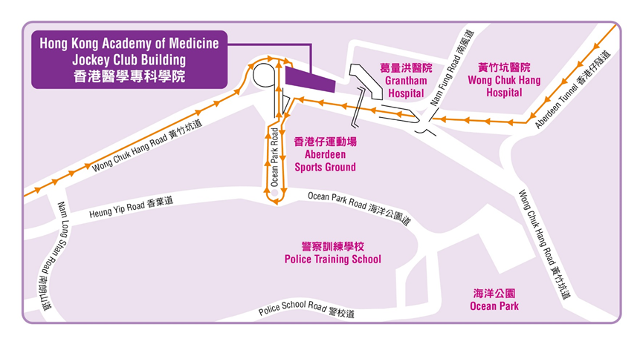
1st – 2nd November 2014 (Saturday & Sunday)

Venue: Hong Kong Academy of Medicine Jockey Club Building
99 Wong Chuk Hang Road, Aberdeen, HKSAR, China
香港黃竹坑道99號香港醫學專科學院賽馬會大樓
www.hkam.org.hk

(Each form should be used for one registration only. It can be photocopied, downloaded from http://www.hkcr.org or obtained from the HKCR secretariat office.)

Please return the completed registration form with payment to:
Conference Department  Hong Kong Academy of Medicine  Room 808, 8/F, HKAM Jockey Club Building  99 Wong Chuk Hang Road  Aberdeen, Hong Kong SAR, China  Attention: Registration Secretariat of HKCR 22nd ASM |  | Tel: (852) 2871 8787  Fax: (852) 2871 8898  Email: HKCR@hkam.org.hk  Please visit our website for updated information:  URL: http://www.hkcr.org

I. Identification (please use block capitals)
Title: Prof. / Dr. / Mr. / Mrs. / Ms. Status: Fellow / member of RCR / HKCR:  YES  NO
Last Name: |  |  |  |  |  | First Name:
Position: |  |  |  |  |  | Department:
Organization / Institute:
Mailing Address:
Telephone: |  | ( ) |  |  |  |  | Facsimile: | ( )
E-mail address:

II. Registration Fees & Method of Payment
Registration fees for delegates include a copy of programme book, coffee breaks and lunch(es) during the meeting period. Conference kits are for full registrants only. All bank charges must be pre-paid.
REGISTRATION FEES FOR LOCAL/OVERSEAS DELEGATES:
 | Fellows & members  of RCR / HKCR | Radiographers, Medical Physicists and Nurses | Other Physicians | Students
Discounted Rate for Early  Bird Registration (Before 31st August 2014 by postage chop) | - HKD 1,300 /  - USD 180 | - HKD 1,100 /  - USD 160 | - HKD 1,800/  - USD 260 | - HKD 700 /  - USD 100
Full Registration (2 Days) | - HKD 1,800 /  - USD 260 | - HKD 1,400 /  - USD 200 | - HKD 2,400 /  - USD 340 | - HKD 1,000 /  - USD 150
Day Registration (on ________ ) | - HKD 900 /  - USD 130 | - HKD 700 /  - USD 100 | - HKD 1,200 /  - USD 170 | - HKD 500 /  - USD 75
Dinner of the Colleges  on 1st November 2014 | ❑ HKD 300 /  USD 50  (Please indicate any special dietary requirements: _________________________________________ )
(The registration fees in USD as quoted above include bank charges for USD bank drafts.)

METHOD OF PAYMENT:
- Cheque in Hong Kong Dollars (HKD) made payable to “HONG KONG ACADEMY OF MEDICINE” enclosed. For overseas delegates, personal cheques are not accepted.
- Bank Draft in US Dollars (USD) made payable to “HONG KONG ACADEMY OF MEDICINE” enclosed.
- Payment by Credit Card in Hong Kong Dollars (HKD) for overseas delegates only. The following credit cards are accepted: VISA, MASTERCARD.
Please charge the total amount above to the following credit card:  Visa  MasterCard

Cardholder Name:
Credit Card No.: |  | Expiry Date: | ( mm / yy )
Cardholder Signature: |  | Date:

NOTE: Your registration will not be processed or confirmed if payment is not forwarded with this form.

III. CME/CPD Accreditation
The 2-day meeting is accredited by Hong Kong College of Radiologists for 12 (Cat. A) CME/CPD Credit Points.
[6.5 points for 1st November 2014 and 5.5 points for 2nd November 2014]

CME/CPD credit points from The Royal College of Radiologists, other Colleges of the Hong Kong Academy of Medicine, MCHK CME Programme and Radiographers Board of Hong Kong are under application.

Please remember to register for your CME/CPD points on both days of the meeting. Programme may be subject to changes.

IV. Personal Data (Privacy) Ordinance
Your name and institute will be included in the list of participants, which may be distributed to delegates, speakers, sponsoring companies and other parties involved in this event and also for our College’s future scientific activities. Please tick box if you do not agree.
I would not like my name to be included in the list of participants. 

V. Cancellation Policy
In the event of cancellation, a refund of the total registration fee paid (minus a 25% administration fee) will be made, on provision of a written notice received by the Secretariat on or before 26th September 2014. After this date, no refund can be made for cancellation. Please note that all refunds will be issued only after the meeting. In case of cancellation due to bad weather or other uncontrollable factors, no refund will be entertained.

Signature: _____________________________________________ Date: _________________________________________

